**Ile never Love thee more**

**being a true Love Song between a young/ Man and a Maid. To a new Tune called, O no, no, no, not yet.[1]**

**Featured edition: ‘London Printed for F. Coles, T. Vere, J. Wright, and J. C[lark]’, Pepys Ballads, III.266 (1674-79)**

Effectively this is two short songs to the same tune, though they’re not actually subdivided on the printed sheet.

[Performance: the first song would be best with a male voice; the second song could either be a single voice, male or female, or sung as a dialogue. In both songs, there is a one-line refrain that cold be sung by a larger group. This was a dance tune so probably not too slow? Accompaniment is up to you, but see the separate list of poss combinations for a suggestion].

[First song]

1. My dear and only love take heed,

how you your self dispose

And let no wandring lovers feed,

on such like looks as those,

Ile marble wall thee round about,

being built without a door,

Where if thy heart but once break out

Ile never love thee more,

1. Let not their oaths (like Vollies shot)

make any breach at all,

For smoothness of their cunning plots,

which way to scale the wall:

For balls of wild fire loud consume,

the shrine that I adore,

But if such smoak about thee fume,

Ile never love thee more.

1. I know thy vertues are so strong,

theyle suffer no sur[p]rise,[2]

Maintain-ed by my love so long,

at last the siege must rise,

And leave the ruler in such health,

and state it was before,

But if thou prove a common wealth,

Ile never [love thee more].

1. Or if by fraud or by consent,

my heart to ruine come,

Ile nere sound Trumpet as I meant,

nor march by sound of Drum,

But hold mine arms and Ensigns up,

thy falshood to deplore,

And after such a common cup,

Ile never [love thee more].

1. Ile do by thee as Nero did

when Rome was set on fire,

Not only all releif [relief] forbid,

but backwards did retire:

And scorn to shed a tear to see,

thy spirit grown so poor,

But smileing sing thus unto thee,

Ile never [love thee more].

1. But if thou wilt continue true

Leander I will prove,

As he to Hero I to you,

will (swimming) drown for love

O be not like to Cressida

as now be lovers store,

That I no cause may have to say,

Ile never [love thee more].

1. If thou like Helena of Greece,

wilt falsifie thy word,

Thy Jason for the golden Fleece

like measure will afford,

And choose some rare Penelope,

with vertues to adore,

That I may justly say to thee,

Ile never [love thee more].

1. But if thy heart like milk white snow

will melt and mollifie,

Or as the Turtle true love show[3]

and for our parting dye,

Then shall our loves fast setled be

upon no sandy shore,

And I will say my love to thee,

Ile love thee evermore.

[Second song]

1. A Young man walk-ed once alone

abroad to take the Air

It was his chance to meet a maid

of beauty passing fair,

He ask-ed her in secrecy,

down by him for to sit,

She answered him with modesty

‘oh no, no, no, not yet’

1. [Man] ‘Forty Crowns I will give thee

sweet heart in good red gold,

To live with me and be my love

say shall the bargain hold’,

[Woman] She answered him most modestly

and with a pregnant wit:

‘A married wife I will not be,

oh no [no no, not yet].

1. Gold and Silver are but dross,

and soon will fade away,

While vertue in a virgins breast,

will have a longer stay,

Then think me not to be so fond,

and of so little wit:

To sell away my liberty,

oh no [no no, not yet].

1. Some of our sex you say are weak

and easie to be won[4],

But you shal find in all my way,

your sugred [= sugared] words Ile shun

I will not overtaken be,

in any thing unfit

Nor trust unto a tempting tongue

oh no [no no, not yet]’.

1. [Man] ‘Oh be not so unkind my dear’,

the young man then replide

‘The tongue doth tell what pain & grief

we lovers do abide,

If hand and heart but once agree,

commanded is the wit

Then say no more my dear to me,

oh no no, [no, not yet]’.

1. [Woman] ‘If I should trust thy words’ quoth she,

‘where falshood doth remain,

To call my Virgins freedom back,

I think it be but vain:

Therefore to chuse a man to wed,

requires the closest wit,

Then let me have a time to say,

oh no, [no, no, not yet]’.

1. [Man] ‘The silver Moon shall shine by day

the golden Sun by night

Ere I leave’ (quoth he) ‘the way,

that leads me to delight

For silence is a grant in love,

and for a Maiden fit,

Then say no more discourteously,

oh no, no, [no, not yet]’.

1. The young man and the maiden then

became united friends,

She liked of him and he of her,

and so their woeing ends,

And she the married life did choose,

as it was reason fit,

where neither of them answered more

oh no, no, no, not yet.

*****************************************

Playford’s version of the tune (from the 1686 edn of *Dancing Master*):

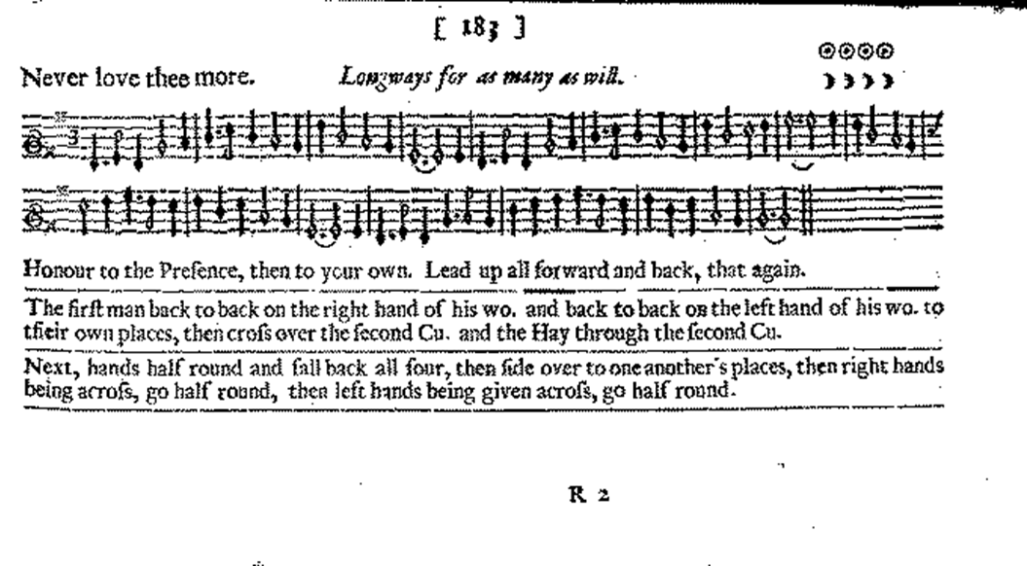

1. There’s a version on Simpson, p. 355, but I prefer Playford’s rendition of the same tune. See below for a scan.
2. There is a small misprint in the original.
3. This refers to the turtle dove, an archetype of romantic devotion.
4. double o in original.